**CSP2101 Assignment2 Portfolio Task1**

**Semester 1, 2020**

**Morium Mostafa Momo**

**10492778**

The code for the Guessage.sh bash script is given below:

# !/bin/sh

#student Name: Morium Mostafa Momo

#student ID: 10492778

# welcome note for the user

echo $'\n**** WELCOME TO GUESSING GAME ****'

echo "Please enter your guess: "

read guess_age

# generate a random number between 20 and 70

(( age = RANDOM % 50 + 20 ))

while [[ $guess_age -ne $age ]]  # continue until the guessed age is not equal to the age

do

    if [[ $guess_age -gt $age ]]  # check wheather the guessed age is greater than  the age

    then

        echo "The guess is too high!"

    else

        echo "The guess is too low!"

    fi

    echo

    echo "Guess a new age: "

    read guess_age

done

echo "The guess is correct!"

echo $'**** THE END ****\n'

# end of the script

A screenshot of the code is also given below:

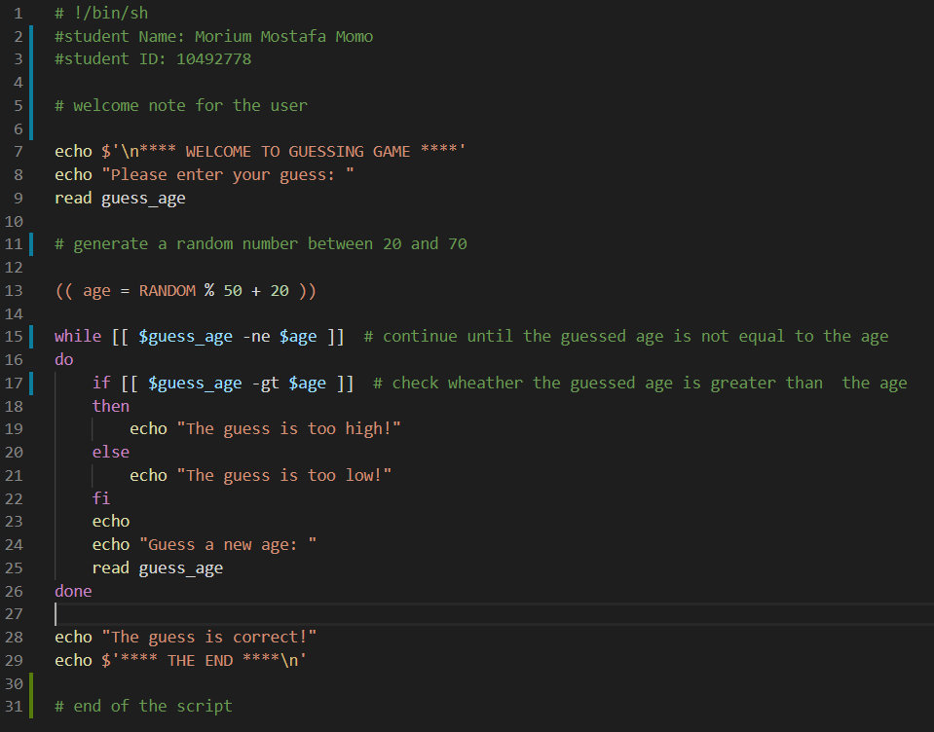

The screenshot of the output when it runs:

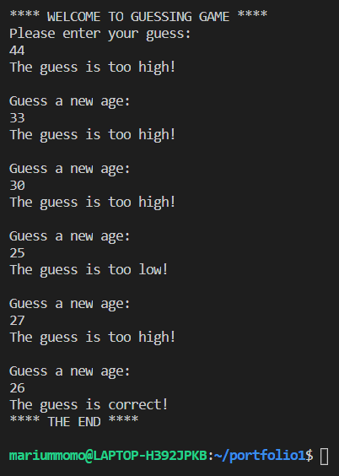

A screenshot for the directory change is also given below:

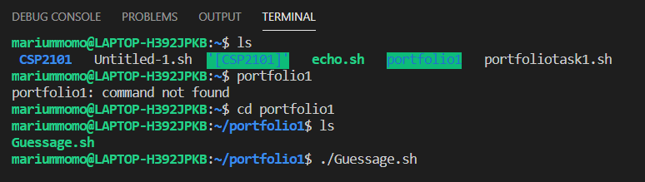

The link for OneDrive saved files:

https://edithcowanuni-my.sharepoint.com/:f:/r/personal/mmomo_our_ecu_edu_au/Documents/Portfolio%20Task%201(scripting)?csf=1&web=1&e=jBbRqs